FOR IMMEDIATE RELEASE—April 24, 2020
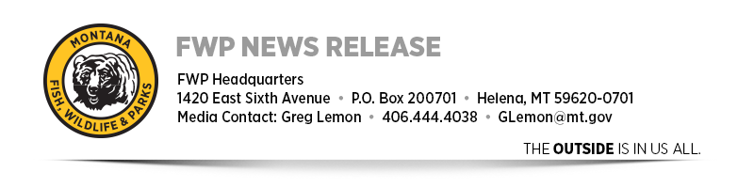
FWP announces updates to COVID-19-related closures and suspensions
People looking to get outside and enjoy spring will continue to have ample opportunities with Gov. Steve Bullock's phased approach to re-opening the state, which was announced Wednesday.
Most of Montana Fish, Wildlife & Parks’ sites typically open and operational at this time of year remain so. This includes all FWP fishing access sites, most state parks and those wildlife management areas that don’t have seasonal closures.
People heading outside still need to keep in mind Montana’s social distancing directives. Per Gov. Bullock’s “Reopening the Big Sky” plan, all who recreate outdoors should “avoid gathering in groups of more than 10 people in circumstances that do not readily allow for appropriate physical distancing.” They are further asked to “exercise frequent sanitation protocols if public facilities are open” and continue to follow all previously established hygiene measures. For more information on Gov. Bullock’s plan, please visit COVID19.mt.gov.
The following FWP updates are in response to Gov. Bullock’s plan announced on Wednesday:
- Overnight camping opportunities will resume at most FWP fishing access sites and state parks on May 1.
- Campers between May 1 and May 15 may encounter reduced amenities or limited services that are typical for the opening of early-season recreational sites. Please check the FWP website for specific site restrictions or closures.
- Group sites, including fishing piers, will open May 1.
- At all sites, as in other aspects of life, social distancing guidelines must be strictly followed.
- Visitor centers, park offices and FWP lobbies are still closed to the public at this time.
- Bannack State Park will remain closed until further notice.
- Float recreation on the Smith River will resume May 5. Between now and then, FWP staff will continue to work with local and federal partners on ways to safely allow recreation in this popular state park and river corridor once recreation activities resume.
- Out-of-state travelers are still required to follow the governor’s 14-day quarantine directive when they come to Montana, as they carry the risk of spreading COVID-19 to Montana residents. Guidance for those directives can be found at fwp.mt.gov/covid19. The directives include the requirements that those in quarantine cannot leave for groceries, recreation, work or any other activity.
- Paddlefish season (yellow tag) closures on the Yellowstone and Lower Missouri rivers are still in effect.
- Paddlefish season (white tag) on the Upper Missouri River will run as usual from May 1 through June 15. However, this year there will be no snag-and-release opportunity. Visit fwp.mt.gov for information about other paddlefishing opportunities later in the year.
- Most wildlife management areas will remain under their normal seasonal closures until the standard May 15 date.
- The suspension of nonresident spring hunting for turkey and black bear will expire April 24. As in other circumstances, out-of-state travelers must follow the governor’s 14-day quarantine directive.
- Hunter education class closures will extend through at least May 7. FWP is working to develop other class opportunities to meet the needs of students, and still align with social distancing guidelines and restrictions on the size of gatherings. As those logistics are finalized, more information will be available.
As the governor’s plan progresses through its three phases, FWP will announce further updates. For more information on FWP’s response to COVID-19, please visit fwp.mt.gov/covid19. For more information on Gov. Bullock’s response, visit https://covid19.mt.gov/.
-fwp-

